Working Families Gift Aid Declaration

Your gift can be worth 25% more to Working Families at no extra cost to you.
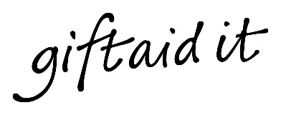
Gift Aid is reclaimed by the charity from the tax you pay for the current tax year. Your address is needed to identify you as a current UK taxpayer.

My Details
Title ____________________ First name__________________________________
Surname ___________________________________________________________
Address ____________________________________________________________
___________________________________________________________________
___________________________________________________________________
Postcode _________________________ Date _____________________________
☐ I am a UK taxpayer and understand that if I pay less Income Tax and/or Capital Gains Tax in the current tax year than the amount of Gift Aid claimed on all my donations it is my responsibility to pay any difference.
Please return this form to: Working Families, c/o Buzzacott LLP, 130 Wood Street, London, EC2V 6DL
Please notify the charity if you:
- want to cancel this declaration
- change your name or home address
- no longer pay sufficient tax on your income and/or capital gains
If you pay Income Tax at the higher or additional rate and want to receive the additional tax relief due to you, you must include all your Gift Aid donations on your Self-Assessment tax return or ask HM Revenue and Customs to adjust your tax code.
From time to time Working Families may contact you about our work. We take your privacy seriously and you can read our policy on our website. You can change how we contact you at any point by calling 020 3833 2050.

